React Lab – ES6 Features Implementation

# Objective

To build a React application demonstrating ES6 features such as map(), arrow functions, and filtering.  
The application displays a list of cricket players and filters out those with scores below 70.

# Output Screenshot

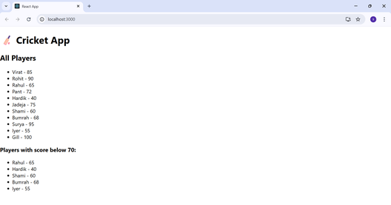

# React Code

## App.js

import React from 'react';  
import ListofPlayers from './ListofPlayers';  
  
function App() {  
 const flag = true;  
  
 return (  
 <div className="App">  
 <h1>🏏 Cricket App</h1>  
 {flag ? <ListofPlayers /> : <div>No Data</div>}  
 </div>  
 );  
}  
  
export default App;

## ListofPlayers.js

import React from 'react';  
  
const players = [  
 { name: "Virat", score: 85 },  
 { name: "Rohit", score: 90 },  
 { name: "Rahul", score: 65 },  
 { name: "Pant", score: 72 },  
 { name: "Hardik", score: 40 },  
 { name: "Jadeja", score: 75 },  
 { name: "Shami", score: 60 },  
 { name: "Bumrah", score: 68 },  
 { name: "Surya", score: 95 },  
 { name: "Iyer", score: 55 },  
 { name: "Gill", score: 100 }  
];  
  
const ListofPlayers = () => {  
 const allPlayers = players.map((p, i) => <li key={i}>{p.name} - {p.score}</li>);  
 const below70 = players.filter(p => p.score < 70);  
  
 return (  
 <div>  
 <h2>All Players</h2>  
 <ul>{allPlayers}</ul>  
  
 <h3>Players with score below 70:</h3>  
 <ul>{below70.map((p, i) => <li key={i}>{p.name} - {p.score}</li>)}</ul>  
 </div>  
 );  
};  
  
export default ListofPlayers;

# ES6 Features Used

- Arrow Functions: Used in the filter method to find players with score below 70.  
- map(): Used to display the list of all players and filtered players.  
- JSX: Used to render the list items dynamically.  
- Conditional Rendering: The `flag` variable determines which component is shown.